**ARTIFICIAL INTELLIGENCE BASED ALL IN ONE PERSONAL ASSISTANT USING SMART MIRROR**

**SEMINAR REPORT**

***Submitted by***

**SAMMED SUNL PATIL - RA1911003020381**

Under the guidance of

**Dr. AMIRTHALAKSHMI.T.M**

**Mr. PRABHU**

***In partial fulfillment for the award of the degree***

***of***

**BACHELOR OF TECHNOLOGY**

***in***

**COMPUTER SCIENCE AND ENGINEERING**

***of***

**FACULTY OF ENGINEERING AND TECHNOLOGY**

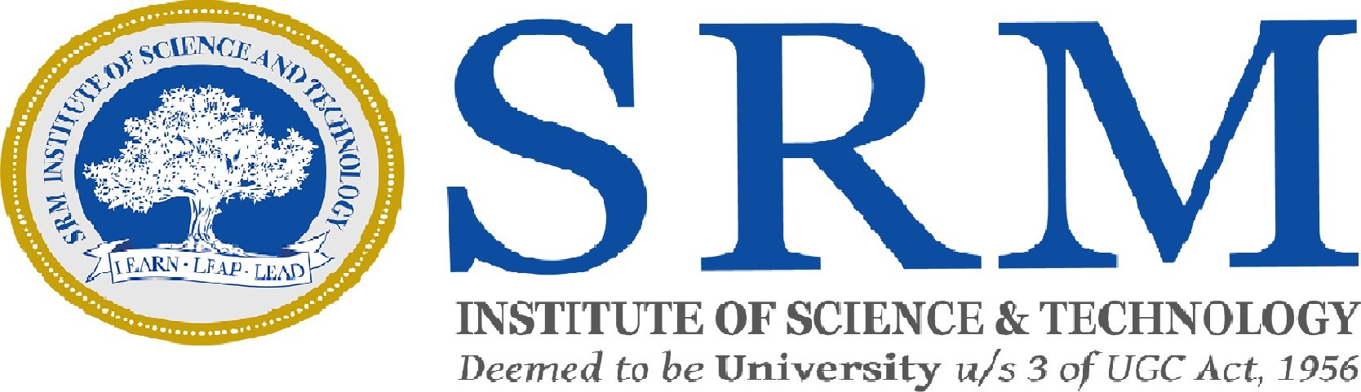

**SRM INSTITUTE OF SCIENCE AND TECHNOLOGY**

**RAMAPURAM CAMPUS, CHENNAI-600089**

**MAY 2022**

# SRM INSTITUTE OF SCIENCE AND TECHNOLOGY

(Deemed to be University Under Section 3 of UGC Act, 1956)

# BONAFIDE CERTIFICATE

Certified that the Seminar-II report titled “**ARTIFICIAL INTELLIGENCE BASED ALL IN ONE PERSONAL ASSISTANT USING SMART MIRROR**” is the bonafide work of “**SAMMED SUNL PATIL [RA1911003020381]**” submitted for the course 18CSP106L Seminar – II. This report is a record of successful completion of the specified course evaluated based on literature reviews and the supervisor. No part of the Seminar Report has been submitted for any degree, diploma, title, or recognition before.

**SUPERVISOR SIGNATURE HOD SIGNATURE**

Dr.Amirthalakshmi.T.M Ph.D., Dr.K.Raja

Assistant Professor Head of Department

Dept. of Computer Science & Dept. of Computer Science & Engineering Engineering

SRM Ramapuram SRM Ramapuram

Submitted for the Viva Voce Examination held on ………………… at SRM Institute of Science and Technology, Ramapuram Campus, Chennai-600089.

**EXAMINER 1 EXAMINER 2**

ii

**ABSTRACT**

The Artificial Intelligence based Smart Mirror can be used to schedule everyday activities, get a live workout guide, check health, outfit, and make-up suggestions. It can also show whether, date, time, motivation and also update of news. A smart mirror is a device that functions as a mirror with additional capability of displaying multimedia data, such as text, images, and videos. This device allows users to access and interact with contextual information, such as weather data, seamlessly as part of their daily routine. In this project, we developed Smart Reflect - a software platform for developing smart mirror applications. The main features of Smart Reflect are threefold: It is modular, lightweight, and extensible; It allows developers to sidestep the sandboxed environment created by web browsers; and it supports plugins written in any programming languages. These improvements alleviate the hardware and software limitations inherent with the use of web browsers as a primary scriptable display method. In this paper, we describe the design and implementation of Smart Reflect and compare it with other similar platforms. We also discuss the potential uses and applications of smart mirrors with regard to the new capabilities that our platform provides.

iii

**TABLE OF CONTENTS**

| CHAPTER  No. | TITLE | PAGE No. |
| --- | --- | --- |
|  | ABSTRACT | iii |
|  | LIST OF FIGURES | v |
|  | LIST OF TABLES | vi |
| 1 | INTRODUCTION OF THE PROJECT | 1 |
| 2 | PROBLEM STATEMENT | 2 |
| 3 | SCOPE & OBJECTIVE | 3 |
| 4 | EXISTING SYSTEM | 4 |
| 5 | LIERATURE SURVEY | 5 |
| 6 | ARCHITECTURE | 10 |
| 7 | PROPOSED WORK & ALGORITHM | 11 |
| 8 | FUTURE SCOPE | 12 |
| 9 | DISADVANTAGES | 14 |
| 10 | CONCLUSION | 15 |

iv

**LSIT OF FIGURES**

| **Sl. No.** | **Name** | **Page No.** |
| --- | --- | --- |
| 1 | Architecture | 9 |
| 2 | Global Market | 14 |

v

**LIST OF TABLES**

| **Sl. No.** | **Name** | **Page No.** |
| --- | --- | --- |
| 1 | Literature Survey | 6 |

vi

1. **INTRODUCTION**

AI based Smart mirror can be equipped with face recognition and voice control features for everyday activities, get a live workout guide, check health, outfit, and make-up suggestions. Smart mirror includes camera, microphone, Raspberry Pi as the main controller, and LED display that is placed behind the mirror. The standard and quality of life is changing vigorously by the help of interactive computing and embedded systems that are being used in our daily life. A variety of devices and products based on this interactive technology have been introduced to the world. With this kind of artificial intelligence and interactive computing, we are provided with a comfortable, user convenient and a very secure personal service. Whether it is a home or a workspace, it makes all the users pretty convenient to work or enjoy the multimedia. We use the mirror multiple times every day to see if we have dressed well or how our hair looks and even do a lot of grooming in front of it. Reflecta is an advancement effort to develop an embedded intelligence onto a mirror and offer enhanced features such as latest news, headlines, weather, and local time corresponding to the user’s location. The Smart Mirror is a stepping stone in development of smart homes with the help of embedded artificial intelligence. It’s found its applications in various workspace as well.

1

1. **PROBLEM STATEMENT**

The recent world has become a place of an intense competition among the people. Human race has become more goal oriented and strive to be the best in all aspects whether its sports, business or entertainment. We all, ultimately, strive to be the best. Following the news, adapting the varied weather conditions are some of the interruptions that hinder our daily progress. Activities like these consume a lot of our time and can be very distracting which might affect our day-to-day activities. People value their appearance greatly and spend a ridiculous amount of time in front of a mirror throughout their daily routine. But spending time with a smartphone, managing daily tasks, while preparing for the day would be a hard task. Therefore, a device with certain technology is required which allows a person to efficiently complete all the work needed for them to prepare for the day. And all of this has to be done at the same time and in one place. Hence, an Artificial Intelligence based Smart Mirror. The objective of Reflecta is to provide an interactive display with the simplest interface to access various information that is needed to prepare well for the day. By using a 2-way mirror and an LCD display information like weather, time, calendar, news, voice controlled AI, YouTube, home automation service and many more functions can be performed simultaneously together.

2

1. **SCOPE AND OBJECTIVE**

Information Display System

Personal Assistant



Fitness and Lifestyle Guide



AI Voice Controlled and Touch screen Interaction

3

1. **EXISTING SYSTEM**

We surveyed existing methods of creating smart interactive mirror system. Smart Mirrors are developed mostly for the purpose to display time, date, and weather forecast. Some also contains To-Do lists, traffic information, and notifications. Later, it got upgraded with music player and voice recognition. Thus, it can be personalized as per the requirements. Similar projects and products to our smart mirror project span a wide range of capabilities and applications. There were much more projects than finished items. Some of the blame can be attributed to the fact that the smart home is still a developing market with production costs that keep the gadgets out of reach of the average user. The fact that there were more projects demonstrates that there is a need to create a smart mirror that is more affordable and functional. Although a company's real products delivered on characteristics, they were either still in development or were already too expensive to be deemed a potential rival. Several attempts have been made to add specific capabilities to mirrors, including both commercial and research-based approaches. However, due to the high amount of space required, such systems are typically infeasible to build.

4

1. **LITERATURE SURVEY**

| **Sl. No.** | **Journal Name** | **Year of Publishing** | **Paper Title** | **Author** | **Description** |
| --- | --- | --- | --- | --- | --- |
| 1. | Toshiba | 2014 | At International Consumer Electronics Show (CES) Toshiba showcased their smart mirror concept. | Toshiba | Their idea was that the smart mirror would be customized for the purpose it would serve in each room. |
| 2. | Microsoft | 2016 | Smart mirror System | Microsoft | Their intention does not seem to be to create a commercial smart mirror to sell to consumers, but rather they unveiled all the details on how to build one and made all the code publicly available at a GitHub repository. |
| 3. | Research by Vaibhav Khanna and Team | 2015 | Interactive mirror with proper embedded intelligence | Vaibhav Khanna, Vash Vardhan, Dhruv Nair and Preeti Pannu | According to their research the Smart Mirror would help in developing smart houses with embedded artificial intelligence, as well as finding its applications in industries. |
| 4. | Research by Gomez-Carmona | 2016 | Multi-user smart mirror system | Gomez-Carmona | Conceived to promote wellness and healthier lifestyles in the work environment through persuasive strategies. |
| 5. | Research by Chidambaram Sethukkarasi | 2014 | Smart Mirror system | M. M. Yusri | Created an intelligent mirror which identifies the user using facial recognition technique and provides services such as recognizing emotions, health parameters, height identification. |
| 6. | Research by M. M. Yusri and Team | 2014 | Smart Mirror system | M. M. Yusri | Relevant information can be traced such as time and date, weather, warning, traffic, and location map. The system applies Sonus technology as a medium of interaction between people and systems |
| 7. | Research by Lakshmi N M and Team | 2015 | Smart Mirror system | Lakshmi N M,Chandana M S and Ishwarya P | Represents an elegant interface for glancing information and also used for thief detection in a home environment. |
| 8. | At 5th International Conference on Future Internet of Things and Cloud Workshops | 2017 | A Mobile-Programmable Smart mirror for Ambient IoT Environment | At 5th International Conference on Future Internet of Things and Cloud Workshops | Describes the design and development of Interactive Smart mirror that offers simplified and customizable services to the home environment. |
| 9. | Published at IEEE Conference publication | 2016 | Smart Mirror for Smart Life | Published at IEEE Conference publication | Describes about the monitoring and controlling of homebased devices with the mirror. |
| 10. | Research by Gomez-Carmona | 2016 | Multi-user smart mirror system | Gomez-Carmona | Conceived to promote wellness and healthier lifestyles in the work environment through persuasive strategies. |

| 11. | 13th International Conference on Signal- Image Technology & Internet-Based Systems | 2017 | Implementation and Customization of a Smart Mirror through a Facial Recognition Authentication and a Personalized News Recommendation Algorithm | 13th International Conference on Signal- Image Technology & Internet-Based Systems | The daily news recommendation predictive model is implemented through the facial recognition algorithm. |
| --- | --- | --- | --- | --- | --- |
| 12. | Research by M. M. Yusri and Team | 2014 | Smart Mirror system | M. M. Yusri | Relevant information can be traced such as time and date, weather, warning, traffic, and location map. The system applies Sonus technology as a medium of interaction between people and systems. |
| 13. | Published at IEEE Conference publication | 2018 | SmiWork: An Interactive Smart Mirror Platform for Workplace Health Promotion | Published at IEEE Conference publication | Describes about a multi-user Smart mirror that promotes wellness and healthier lifestyle. |
| 14. | Published at International Journal of Advance Research | 2015 | The Smart Mirror | Published at International Journal of Advance Research | The daily news recommendation predictive model is implemented through the facial recognition algorithm. |
| 15. | Published at International Journal Of Electrical, Electronics And Data Communication | 2017 | Design and development of a smart mirror using Raspberry pi | Published at International Journal Of Electrical, Electronics And Data Communication | Gives the design of futuristic mirror and development of mirror using Raspberry pi. |

9

1. **ARCHITECTURE**

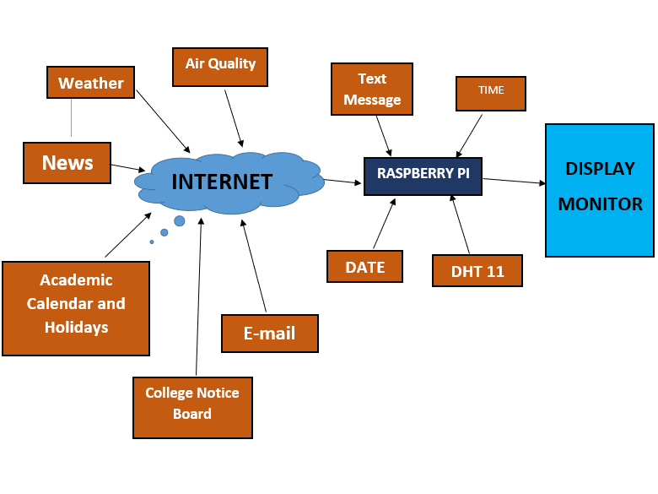

10

1. **PROPOSED WORK**

* A frame for the mirror is built and attached to the 2-way see through mirror.
* Front side of the frame is for the viewing of user and on the other side is where all the components are.
* An LED is attached to display with the frame and connect the LCD display with the raspberry pi via HDMI cable.
* USB microphone and USB web were then connected with the raspberry pi.
* Finally, the power source for both the raspberry pi and LCD display was established

11

1. **FUTURE SCOPE**

* The smart mirror is also known as virtual mirror.
* The smart is the mirror embedded with electronic and smart technologies such as IoT, augmented reality, high quality electronic displays and many others technology.
* Additionally, smart mirror can control using smart phones, computers or tablets. Smart mirror most used in automotive industry and in retail shop to give better comfort to the users.
* Many luxury retail shops used smart mirror to offers virtual dressing room to the customers.
* The smart mirror has wide application in various sectors such as automotive, healthcare, retail and marketing, consumer and others.

12

**GLOBAL MARKET**

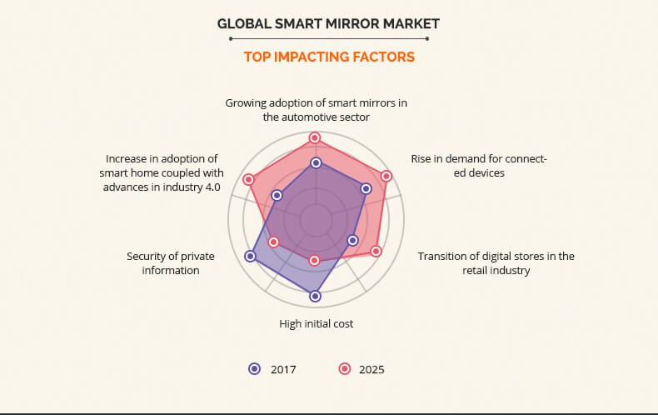

13

1. **DISADVANTAGES**

Cost production for making smart mirror is too high. Many efforts are made following the objective of adding special capabilities to mirrors, each business and research-based approaches. However, such systems aren’t feasible to implement such applications. The system act as an interactive mirror interface. Distinguish between all users and provide the corresponding customized services. Allow for custom user profile management where the user creates his/her own profile that is to be stored on the database server of the proposed system. The Magic Mirror dashboard shows the weather, calendar you choose, current time by using python tools. This product would be useful for busy individuals that want to multitask and stay informed while on the go.

14

1. **CONCLUSION**

As a conclusion, the application is the new technology for smart life. We have designed a futuristic smart mirror that provides natural interaction between users and the ambient home services. The mirror display is provided by a flat LED display monitor which displays all the necessary information which are useful for the user. The mirror also provides a picture-in-picture sub-display to facilitate the display. The system can be made much more useful to the users by adding more functionality like integrating light settings, speech processing, etc. The facial recognition technology used can be future enhanced as a means of security. Adding security means that no one can try to access sensitive data that maybe displayed on your mirror via the use of APIs. We believe that the future of the home will be a brilliantly connected ecosystem of smart technology designed to make your life easier, more enjoyable, and efficient. Obviously there are a ton of opportunities in the home for technology integration but a mirror is one of the best places to start.

15